**Case Assignment Questions**

**FIN 535: Mergers and Acquisitions**

**Peking University HSBC Business School**

**Case Study: H.J. Heinz M&A**

**Due on: Thursday, June 5th, 2025**

***Question 1.*** Discuss the positions of various stakeholders, including Heinz shareholders, management, employees, and citizens of Pittsburgh.

***Answer:***

*1. Positions of stakeholders*

From a shareholder perspective, the acquisition deal was largely favorable. The offer price of $72.50 per share represented a 20% premium over Heinz’s stock price the day before the announcement and approximately a 30% premium over the fair value estimate of $56 provided by analysts such as Morningstar. The deal provided an exit for shareholders after years of pressure, notably from activist investor Nelson Peltz (Trian Fund) starting in 2006. Peltz had demanded strategic changes, including a potential sale, due to poor performance. The acquisition delivered on this demand at a high price. Besides, equity analysts widely endorsed the transaction, emphasizing the generous valuation and the credibility of the buyers. The nearly unanimous shareholder approval on March 30, 2013, confirmed this enthusiasm. In addition, shareholders benefitted from strong financial protections, including a $1.4 billion reverse termination fee payable by the buyers if the deal fell through.

*2. Heinz Management*

Management, led by CEO William Johnson, executed a calculated transition from resistance to endorsement. Despite initially declaring Heinz "not for sale" on January 10, 2013, Johnson leveraged the board’s advisors to force a 3.6% price increase ($70→$72.50/share) within two weeks—securing an additional $800M in shareholder value. His cooperation ensured board approval while extracting a public commitment to retain Pittsburgh operations, mitigating community backlash. However, Johnson’s 31-year tenure (13 as CEO) ended abruptly as 3G installed Bernardo Hees, signaling management’s ultimate sacrifice: prioritizing immediate shareholder returns over continuity. This reflects a fiduciary victory—maximizing exit value—while accepting personal displacement, acknowledging Heinz’s limited growth runway under existing leadership. Johnson’s legacy became facilitating a premium exit rather than long-term stewardship.

*3. Heinz Employees*

The position of Heinz employees was highly uncertain and likely negative, marked by significant anxiety over potential job losses. This stemmed from several factors: First, Heinz's 2006 restructuring under activist pressure eliminated 2,700+ jobs and closed 15 factories, setting a concerning precedent. Second, acquirer 3G Capital had a well-known reputation for aggressive cost-cutting in portfolio companies like Burger King – aligning with their stated goal of "realizing operational efficiencies" at Heinz. Third, while buyers and management claimed "virtually zero synergies" and promised independence, employees and analysts were deeply skeptical, understanding efficiency drives often mean workforce reductions. Finally, no commitments were made regarding job security or plant closures, leaving employees vulnerable despite the Pittsburgh HQ guarantee.

*4. Citizens of Pittsburgh*

For the city of Pittsburgh, where Heinz had been headquartered since 1900, the acquisition triggered concerns about local economic and cultural impacts. The Heinz brand was deeply intertwined with Pittsburgh’s identity, from the company’s founding roots to the naming rights of Heinz Field, home of the Pittsburgh Steelers. To mitigate public backlash, CEO Johnson explicitly vowed to maintain operations in Pittsburgh during negotiations, addressing civic anxieties about economic fallout and preserving the Heinz legacy (e.g., naming rights to Heinz Field stadium). Nevertheless, latent risks persisted—potential job cuts or scaled-back community engagement under 3G’s efficiency-focused model threatened local economic stability.

***Question 2.*** What was the acquisition premium? Was this reasonable?

***Answer:***

*1. Acquisition Premium Calculation*

The acquisition premium refers to the acquisition price compared to the target company’s share price one day prior to announcement of the acquisition. The final offer price by the acquirers (3G Capital and Berkshire Hathaway) was $72.50 per share; According to Exhibit 1(HEINZ SHARE PRICE), Heinz’s closing share price one day before the announcement (February 12, 2013) was approximately $60.40. This is explicitly confirmed in the case: “Heinz’s acquisition price was approximately 20% above the company’s previous day closing share price”.

.

*2. Reasonable Grounds for Acquisition Premium*

The 20% acquisition premium was reasonable based on multiple factors outlined in the case:

* **Industry Conditions & Growth Potential:** The food industry was mature, but Heinz had significant growth opportunities in emerging markets. The acquirer was willing to pay a premium for its future earnings to achieve investment strategy and value-added expectations.
* **Favorable Financing Environment:** Low interest rates (10-year Treasury yield at 1.8%) reduced borrowing costs, enabling higher leverage and justifying a higher price.
* **Target’s Intrinsic Value:** Heinz was a century-old global brand with stable global distribution networks and strong cash flow (2012 EBITDA of $1.947 billion), which was in line with the preferences of the acquirer. The operational efficiency and cost optimization capabilities of 3G Capital can enhance the expected value.
* **Historical Precedent:** The 20% premium fell within the typical range of historical acquisition premiums, which Figure 1 shows often clustered between 20% and 30%.
* **Fairness Opinions & Analyst’s Comments:** Advisors for both Heinz (Bank of America Merrill Lynch, Centerview, Moelis & Co.) and the buyers (J.P. Morgan, Lazard, Wells Fargo) provided fairness opinions, concluding the offer was fair from a financial perspective. Morningstar called it a “fabulous deal”, representing a nearly 30% premium to their standalone fair value estimate of $56; RBC Capital Markets viewed it as a “good deal for HNZ shareholders”.

In conclusion, while Heinz faced challenges (e.g., minimal near-term EBIT growth, lack of estimated synergies), the 20% acquisition premium was reasonable. It aligned with historical norms, reflected Heinz’s strong brand, cash flow, and emerging market potential, was supported by favorable financing conditions and was validated by multiple independent fairness opinions and positive analyst assessments.

***Question 3.*** Complete a valuation of Heinz for this acquisition based on the provided actual financial information. Develop a football field valuation analysis.

***Answer:***

1. **Relative Valuation**

**1.1. The Universe of Comparable Companies**

For relative valuation 12 peer companies were selected, which include:

|  |  |  |
| --- | --- | --- |
| **No.** | **Company Name** | **Main Business** |
| 1 | Campbell | U.S. simple meals, global baking and snaking, international simple meals and beverages, U.S. beverages, North America food service |
| 2 | ConAgra Foods | The largest private brand packaged food business in North America and strong commercial food presence |
| 3 | General Mills | A leading global manufacturer and marketer of food products. Manufactures products in 16 countries and markets in more than 130 worldwide. |
| 4 | Groupe Danone | Fresh dairy products, beverages, biscuits, and cereal products. |
| 5 | Hershey | The largest producer of quality chocolate in North America and global leader in chocolate and sugar confectionery products. Markets in more than 130 counties worldwide. |
| 6 | Kellogg | Manufacturing and marketing of ready-to-eat cereal and convenience foods. Manufactures products in 18 countries and markets in more than 180. |
| 7 | Kraft | One of the largest consumer packaged food and beverage companies in North America and worldwide. |
| 8 | Mondelez | One of the world’s largest snack companies. Manufactures and markets products in approximately 165 countries. Number one in biscuits, chocolate, candy, and powers beverages. |
| 9 | Nestle S.A. | Number one food and drink company in the world in terms of sales and coffee market. A big player in the pet food business |
| 10 | PepsiCo | Leading global food and beverage company. Distributes products in more than 200 countries through direct-store delivery. Owns numerus valuable trademarks. |
| 11 | Unilever | One of the world’s leading suppliers of food, home and personal care products. Its portfolio includes some of the world’s best-known brands. |
| 12 | Smucker | U.S. retail coffee, U.S. retail consumer foods, international foodservice |

**1.2. Growth Analysis**

Performing growth-analysis we excluded Kraft due to unavailability of the data and Mondelez being an outlier. The graph above shows that *General Mills, Kellogg, Nestle PepsiCo, Unilever and Smucker* showed a very similar pattern during the observed period, while *ConAgra Foods, Hershey and Group Danone* seem to outperform Heinz, and *Campbell with Nestle S.A.* – underperform. Growth pattern mainly reflects the development stage that a company currently is being on. Therefore, in case of convergence in valuation results, the ones that are based on the companies with more similar growth pattens are more preferable.

**1.3. Ratios and Trading Multiples**

Several trading multiples and ratios for the 2012 financial year will be used to reflect the market conditions and make the valuation of Nestle, comparable to its peers. We will use median in our calculations.

|  |  |  |  |  |  |  |
| --- | --- | --- | --- | --- | --- | --- |
| **Multiple** | **P/E** | **EV/EBITDA** | **EV/FCF** | **P/B** | **P/S** | **PEG** |
| Mean | 15.8x | 10.2x | 24.9x | 5.8x | 1.6x | 5.8x |
| Median | 15.1x | 10.1x | 22.6x | 4.3x | 1.5x | 4.3x |

Nestle Financials (last 12 months):

|  |  |  |  |  |  |
| --- | --- | --- | --- | --- | --- |
| **ESP** | **EBITDA** | **\*FCF** | **Book Value** | **Sales** | **EGR in EPS** |
| 3.13 | 2 057 | 1 463 | 8.82 | 11 675 | 4% |

**1.4 Valuation**

* **P/E Ratio:**

* **EV/EBITDA:**
* **EV/FCF:**
* **P/B Ratio:**

* **P/S Ratio:**

* **PEG:**

1. **DCF Valuation**

**2.1. Projected Cash Flows**

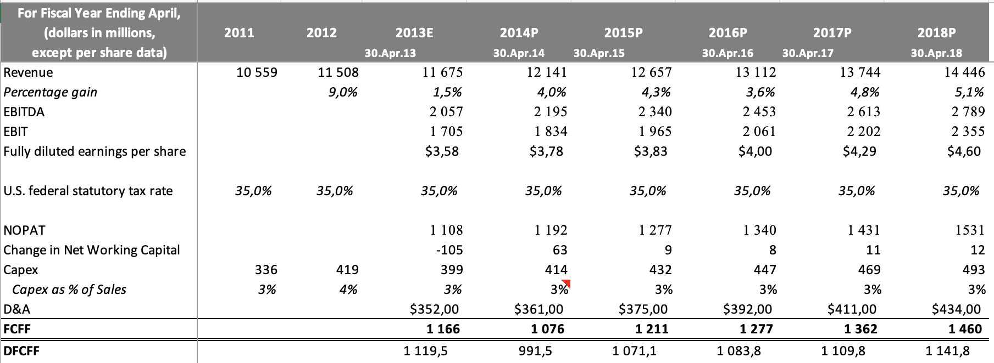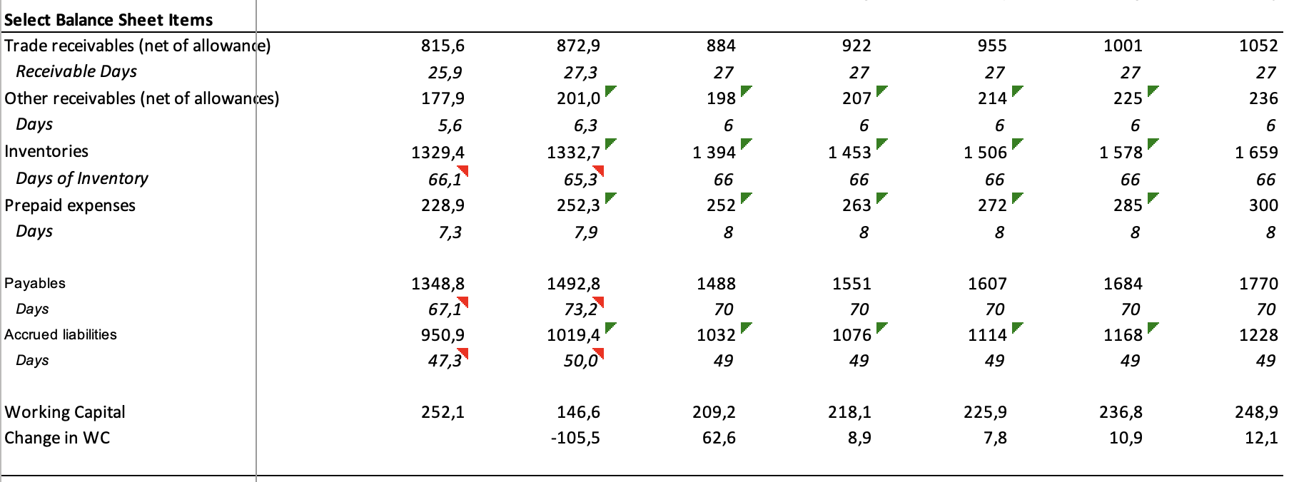

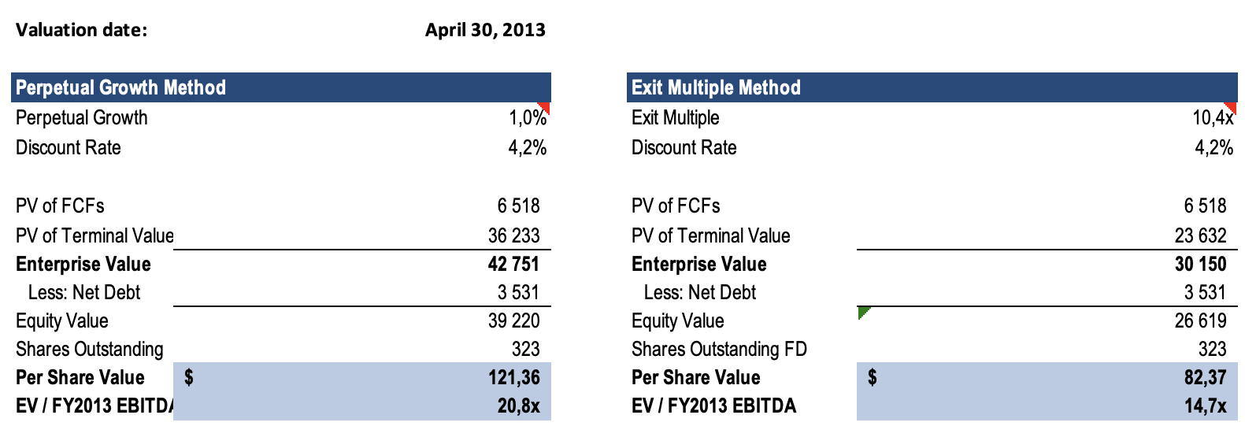

**2.2. WACC**

* **Cost of Equity (CAPM):**
* **Cost of Debt:** Weighted-average interest rate on long-term debt is equal to 4.7%

**2.3. Terminal Value (PGM)**

**2.4. Terminal Value (EM)**

**2.5.1. Valuation PGM**

**2.5.2. Valuation EM**

1. **Precedent Transactions Analysis**

Median EV/LTM_EBITDA = 10.4x

Heinz 2012Y EBITDA = 2 057

1. **Valuation Summary (in USD per share)**

|  |  |  |  |  |  |  |  |  |
| --- | --- | --- | --- | --- | --- | --- | --- | --- |
| Relative | | | | | | PT | DCF | |
| P/E | EV/EBITDA | EV/FCF | P/B | P/Sales | PEG | PG | EM |
| 47.33 | 53.36 | 91.40 | 37.91 | 54.19 | 53.91 | 55.27 | 121.36 | 82.37 |

From the box-plot below we can see the median value among our valuation results that equals 68.34 USD. Fair deal price is estimated to be between 50.35 USD and 86.88 USD per share. More specifically, it is around median value or slightly higher (70 USD per share), closer to the DCF valuation prices that we consider more reliable than the other ones.

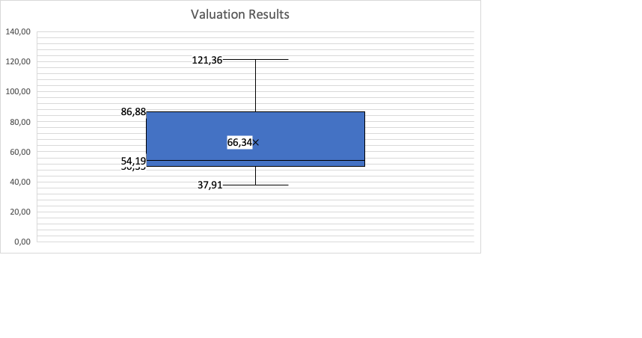

1. **Sensitivity Analysis**

|  |  |  |  |  |
| --- | --- | --- | --- | --- |
| **Share Price Sensitivity** | | | | |
|  |  | *Perpetual Growth Rate* | | |
|  |  | **0,75%** | **1,00%** | **1,25%** |
|  | **3,2%** | $163,72 | $181,62 | $204,11 |
| *Disc* | **3,7%** | 133,65 | 145,47 | 159,71 |
| *Rate* | **4,2%** | 112,94 | **121,36** | 131,22 |
|  | **4,7%** | 96,37 | 102,51 | 109,54 |

|  |  |  |  |  |
| --- | --- | --- | --- | --- |
| **EV / EBITDA Multiple Sensitivity** | | | | |
|  |  | *Perpetual Growth Rate* | | |
|  |  | **0,75%** | **1,00%** | **1,25%** |
|  | **3,2%** | 27,4x | 30,3x | 33,8x |
| *Disc* | **3,7%** | 22,7x | 24,6x | 26,8x |
| *Rate* | **4,2%** | 19,5x | **20,8x** | 22,3x |
|  | **4,7%** | 16,9x | 17,8x | 18,9x |
|  |  |  |  |  |
| **Share Price Sensitivity** | | | | |
|  |  | *Exit Multiple in FY2018* | | |
|  |  | **9,4x** | **10,4x** | **11,4x** |
|  | **3,20%** | $78,54 | $85,92 | $93,29 |
| *Disc* | **3,70%** | 76,89 | 84,08 | 91,28 |
| *Rate* | **4,18%** | 75,34 | **82,37** | 89,40 |
|  | **4,70%** | 73,72 | 80,58 | 87,44 |

|  |  |  |  |  |
| --- | --- | --- | --- | --- |
| **EV / EBITDA Multiple Sensitivity** | | | | |
|  |  | *Exit Multiple in FY2018* | | |
|  |  | **9.4x** | **10.4x** | **11.4x** |
|  | **3.18%** | 14.1x | 15.2x | 16.4x |
| *Disc* | **3.68%** | 13.8x | 14.9x | 16.1x |
| *Rate* | **4.18%** | 13.6x | **14.66x** | 15.8x |
|  | **4.68%** | 13.3x | 14.4x | 15.5x |

***Question 4.***Why did this transaction propose zero synergy? Discuss potential synergies that could be realized.

***Answer:***

*1. Why Did the Transaction Propose Zero Synergies?*

The decision to explicitly state "zero synergies" in the Heinz acquisition was driven by three key factors, as outlined in the case documentation:

* **Commitment to Independence:** 3G Capital and Berkshire Hathaway emphasized that Heinz would operate as a standalone subsidiary post-acquisition. This included retaining its existing management team (e.g., appointing Bernardo Hees, former Burger King CEO, as Heinz’s new CEO) and maintaining its brand identity. The "pure food company" positioning (as stated in Heinz’s mission) was prioritized to avoid diluting its heritage.
* **Lack of Strategic Overlap:** Despite Berkshire’s ownership of complementary brands like See’s Candies and 3G’s stake in Burger King, the firms concluded that cross-industry synergies were minimal. For example: Heinz’s high-margin, slow-moving consumer goods (e.g., ketchup, baby formula) contrasted with 3G’s focus on fast-food efficiency (high-volume, low-cost operations). Cultural differences in product development (e.g., Heinz’s premium branding vs. 3G’s cost-cutting ethos) made integration risky.
* **Financial Leverage as an Alternative:** 3G’s typical strategy involves aggressive cost-cutting (e.g., factory closures, layoffs) to boost margins. However, Heinz already boasted strong operational metrics pre-acquisition (e.g., 17.3% EBITDA margins in 2012, above the food industry average of ~8.5%). The acquirers likely viewed further margin expansion through synergies as unnecessary.

*2. Potential Synergies That Could Have Been Realized*

While publicly dismissed, several synergies existed in theory:

(1) Cost-Side Synergies:

* **Supply Chain Consolidation:** Heinz’s global production network (57 countries) could have shared logistics and procurement with 3G-backed firms (e.g., Burger King’s food suppliers), leveraging scale to reduce raw material costs.
* **Plant Optimization:** Closing underutilized U.S. plants (as Heinz did in 2006) and shifting production to lower-cost emerging markets (where Heinz sales grew 108% in 2012) could have cut expenses.

(2) Revenue-Side Synergies

* **Cross-Selling Opportunities:** Berkshire’s foodservice brands (e.g., Dairy Queen) could have bundled Heinz condiments into meal deals, while Heinz’s infant nutrition products might have paired with 3G’s health-focused investments.
* **Emerging Market Penetration:** Leveraging Heinz’s established distribution in high-growth regions (e.g., India, China) for 3G’s portfolio companies (e.g., Burger King) could have accelerated market entry.

(3) Management/Operational Synergies

* **Zero-Based Budgeting:** 3G’s cost-control methodology might have streamlined Heinz’s marketing spend (industry average 15% of revenue) or administrative overhead.
* **Digital Transformation:** Berkshire’s tech investments (e.g., cloud services) could have modernized Heinz’s supply chain analytics to mitigate currency risks highlighted in the case.

(4) Financial Synergies

* **Debt Restructuring:** Replacing Heinz’s $4.78 billion debt (2012 figure) with Berkshire’s cheaper capital (e.g., AAA-rated bonds at 2.2% in 2012) could have saved tens of millions annually.
* **Tax Optimization:** Relocating Heinz’s headquarters to Delaware (Berkshire’s base) might have slashed corporate taxes (Delaware’s rate: 8.7% vs. Pennsylvania’s 9.99%).

***Question 5.***What was the market reaction to the acquisition announcement, including share price and equity analyst commentary?

***Answer:*** The market responded positively to Berkshire Hathaway and 3G Capital's announced acquisition of H.J. Heinz, reflected in a rising share price and favorable analyst commentary.

*1. Share Price Reaction*

Immediate Surge: As shown in Exhibit 1, Heinz’s stock price rose 19.9% on the announcement day (February 14, 2013), jumping from $60.48 (previous close) to the acquisition price of $72.50 per share. This sharp increase reflected investor approval of the premium and the credibility of the buyers (Berkshire Hathaway and 3G Capital).

*2. Equity Analyst Commentary*

1. Morningstar (Erin Lash):
   1. Key Quote: "This is a fabulous deal for Heinz shareholders, representing a nearly 30% premium to our stand-alone $56 fair value estimate."
   2. Assessment: Deemed the transaction "financially attractive" and anticipated no regulatory roadblocks.
2. RBC Capital Markets (Edward Aaron):
   1. Key Quote: "We view this acquisition as a good deal... considering the rich multiple paid, especially for a financial transaction."
   2. Assessment: Praised the premium but noted Heinz’s "challenged fundamentals" (e.g., minimal EBIT growth). Highlighted positive implications for the broader packaged foods sector.
3. Credit Suisse (Robert Moskow):
   1. Key Quote: "Low borrowing costs give private equity firepower... [Heinz’s] strong cash flows allow for high financial leverage."
   2. Assessment: Emphasized Berkshire’s involvement as a validation of Heinz’s brand strength and cash flow discipline. Doubted rival bids due to the deal’s scale ($28B) and the consortium’s financial capacity. Noted potential for margin expansion from Heinz’s emerging markets growth and IT investments.